Name of student

Name of professor

University

Course

Date

**Data analysis;**

The first process is to clean the data by removing any empty values and fields in the data. The null values are then replaced by the value of “NOT AVAILABLE “, in the respective cells. The next step is to categorize the zones alongside the total sum of the net revenues sales for the ZIPS.

The below is the illustration for the heat maps generated from the zip codes and the corresponding total revenues from the same zip locations. The sample size was reduced to about 69 values and then ordered from largest to smallest values for easier analysis.

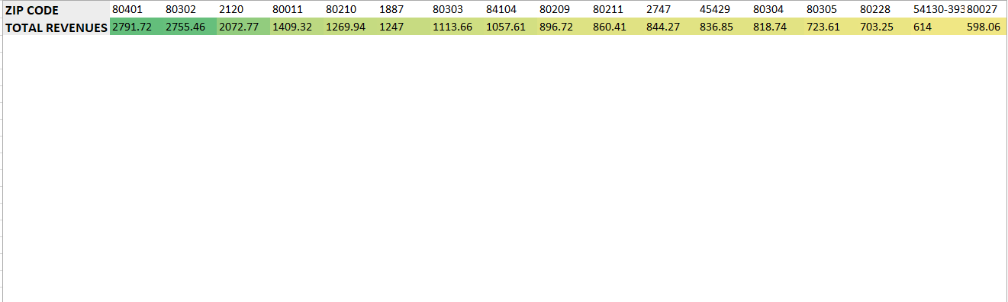

For the low performing zones

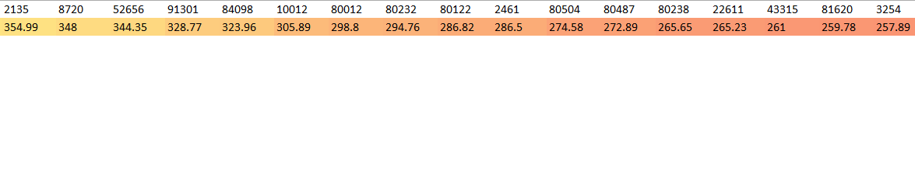

**Analyzing the US ZIP sales states on Studio**

library(tidyverse)

library(sf)

library(plotly)

states <- read_sf("/data") %>%

  st_zm() %>%

  mutate(sales= (per_state / (1000*1000)) %>% round(2))

  g <- ggplot(states) +

  geom_sf(aes(fill=water_km2)) +

  scale_fill_distiller("sales amount", palette="Spectral") +

  ggtitle("Sales by state")

ggplotly(g)

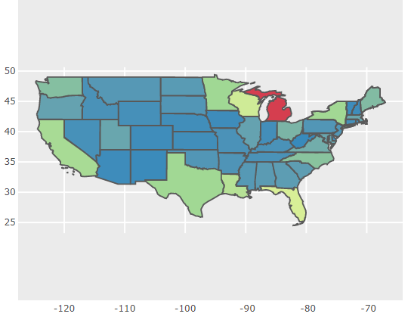

Blue means higher sales, jungle green means moderate sales in these regions and read means low sales

**Proposed marketing plans**

The proposed marketing plans should focus on the regions that are experiencing the low sales in the ZIP locations. These regions are highlighted as below:



Some of the factors that could be taken into consideration include:

1. Social cultural status of the people staying around
2. The competitor activities in these low performing regions
3. Marketing strategies that could accumulate more clients

Some of the marketing strategies that could be used include, social media marketing, digital posters, main stream media and even SMS.